basic

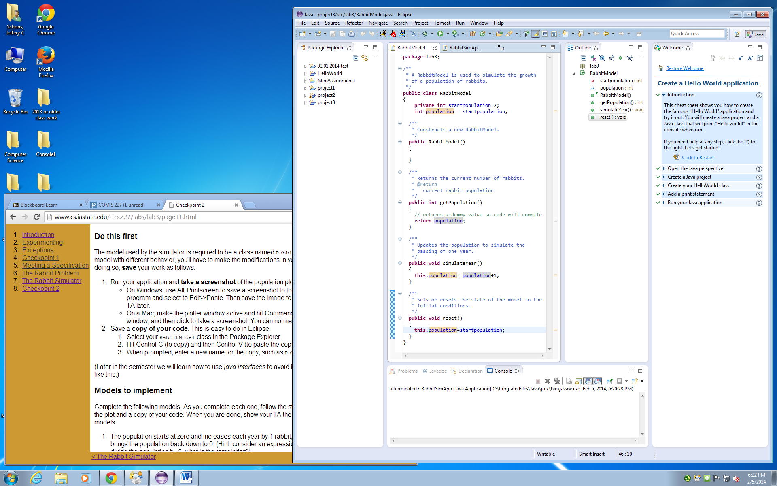

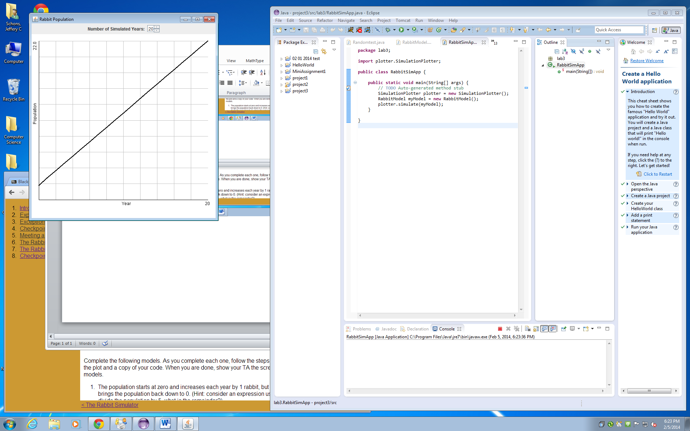

**package** lab3;

/**

* A RabbitModel is used to simulate the growth

* of a population of rabbits.

*/

**public** **class** RabbitModel

{

**private** **int** startpopulation=2;

**int** population = startpopulation;

/**

* Constructs a new RabbitModel.

*/

**public** RabbitModel()

{

}

/**

* Returns the current number of rabbits.

* **@return**

* current rabbit population

*/

**public** **int** getPopulation()

{

// returns a dummy value so code will compile

**return** population;

}

/**

* Updates the population to simulate the

* passing of one year.

*/

**public** **void** simulateYear()

{

**this**.population= population+1;

}

/**

* Sets or resets the state of the model to the

* initial conditions.

*/

**public** **void** reset()

{

**this**.population=startpopulation;

}

}

**package** lab3;

**import** plotter.SimulationPlotter;

**public** **class** RabbitSimApp {

**public** **static** **void** main(String[] args) {

// **TODO** Auto-generated method stub

SimulationPlotter plotter = **new** SimulationPlotter();

RabbitModel myModel = **new** RabbitModel();

plotter.simulate(myModel);

}

}

For **modle 1**

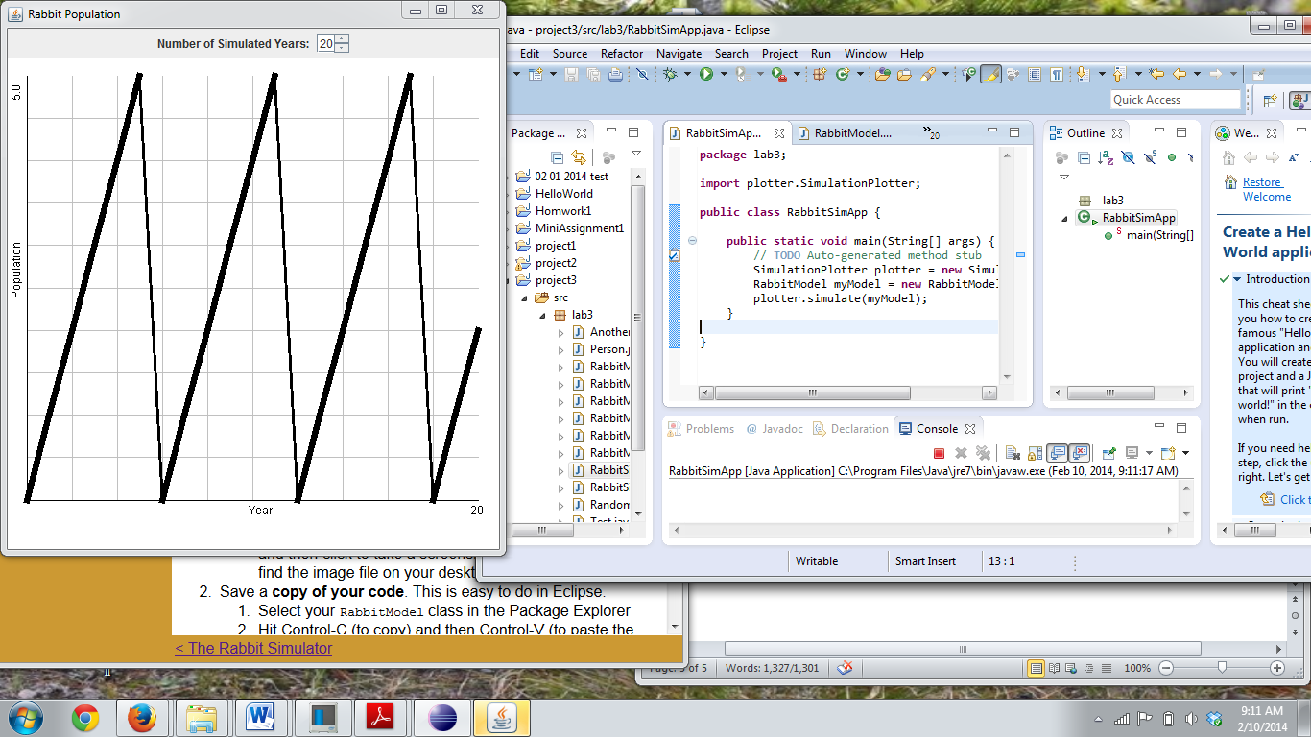

**package** lab3;

/**

* A RabbitModel is used to simulate the growth

* of a population of rabbits.

*/

**public** **class** RabbitModel

{

**private** **int** startpopulation=0;

**int** population = startpopulation;

/**

* Constructs a new RabbitModel.

*/

**public** RabbitModel()

{

}

/**

* Returns the current number of rabbits.

* **@return**

* current rabbit population

*/

**public** **int** getPopulation()

{

// returns a dummy value so code will compile

**return** population;

}

/**

* Updates the population to simulate the

* passing of one year.

*/

**public** **void** simulateYear()

{

**if**(population>4)

{

**this**.population=0;

}

**else**

{

**this**.population= population+1;

}

}

/**

* Sets or resets the state of the model to the

* initial conditions.

*/

**public** **void** reset()

{

**this**.population=startpopulation;

}

}

**Model 2**

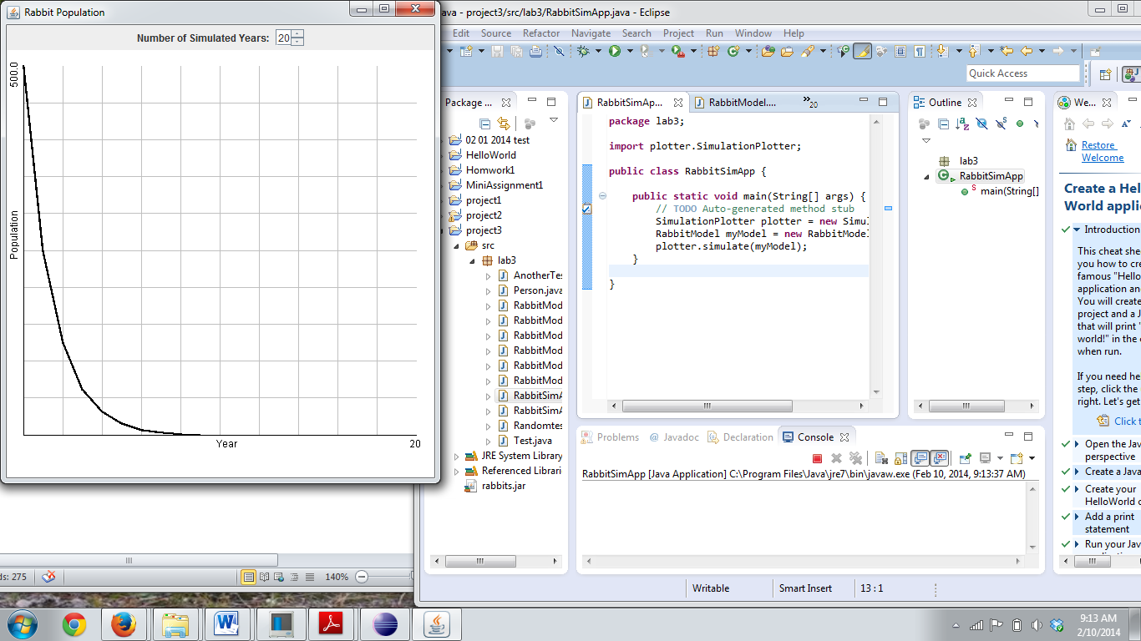

**package** lab3;

/**

* A RabbitModel is used to simulate the growth

* of a population of rabbits.

*/

**public** **class** RabbitModel

{

**private** **int** startpopulation=500;

**int** population = startpopulation;

/**

* Constructs a new RabbitModel.

*/

**public** RabbitModel()

{

}

/**

* Returns the current number of rabbits.

* **@return**

* current rabbit population

*/

**public** **int** getPopulation()

{

// returns a dummy value so code will compile

**return** population;

}

/**

* Updates the population to simulate the

* passing of one year.

*/

**public** **void** simulateYear()

{

**this**.population= population/2;

}

/**

* Sets or resets the state of the model to the

* initial conditions.

*/

**public** **void** reset()

{

**this**.population=startpopulation;

}

}

**Model 3 for Random 137**

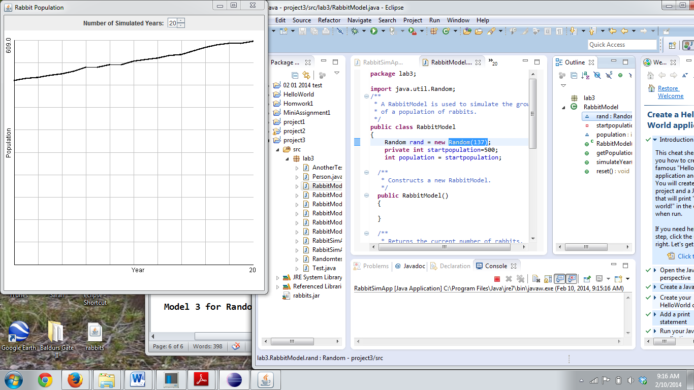

**package** lab3;

**import** java.util.Random;

/**

* A RabbitModel is used to simulate the growth

* of a population of rabbits.

*/

**public** **class** RabbitModel

{

Random rand = **new** Random(137);

**private** **int** startpopulation=500;

**int** population = startpopulation;

/**

* Constructs a new RabbitModel.

*/

**public** RabbitModel()

{

}

/**

* Returns the current number of rabbits.

* **@return**

* current rabbit population

*/

**public** **int** getPopulation()

{

// returns a dummy value so code will compile

**return** population;

}

/**

* Updates the population to simulate the

* passing of one year.

*/

**public** **void** simulateYear()

{

**this**.population= population + rand.nextInt(11);

}

/**

* Sets or resets the state of the model to the

* initial conditions.

*/

**public** **void** reset()

{

**this**.population=startpopulation;

}

}

Model 4

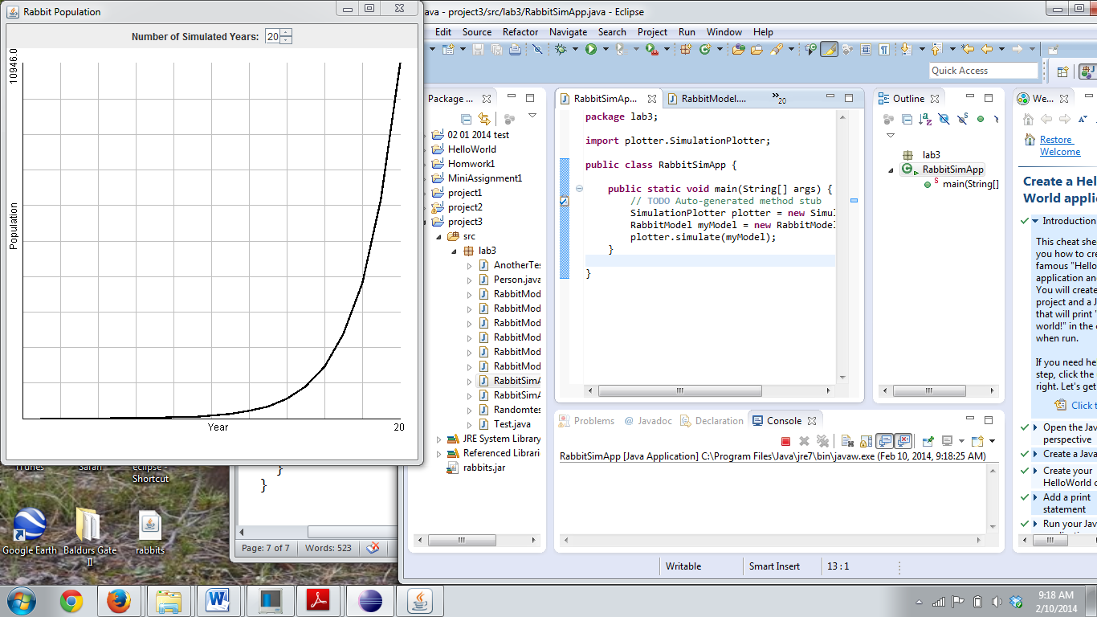

**package** lab3;

/**

* A RabbitModel is used to simulate the growth

* of a population of rabbits.

*/

**public** **class** RabbitModel

{

**private** **int** startpopulation=1;

**int** population = startpopulation;

**int** lastyear=1;

**int** yearbefore=0;

/**

* Constructs a new RabbitModel.

*/

**public** RabbitModel()

{

}

/**

* Returns the current number of rabbits.

* **@return**

* current rabbit population

*/

**public** **int** getPopulation()

{

// returns a dummy value so code will compile

**return** population;

}

/**

* Updates the population to simulate the

* passing of one year.

*/

**public** **void** simulateYear()

{

**this**.population= lastyear + yearbefore;

**this**.yearbefore = lastyear;

**this**.lastyear = population;

}

/**

* Sets or resets the state of the model to the

* initial conditions.

*/

**public** **void** reset()

{

**this**.population=startpopulation;

**this**.lastyear=1;

**this**.yearbefore=0;

}

}